W**EEKLY PROGRESS REPORT**

BY ANURAG SINGH

MUSIC PLAYER APP

* DATE:7/8/23
* PROJECT OVERVIEW:

The goal of this project is to develop a music player app for android that allows users to play audio files, create playlists, manage their music library, and provide a smooth and intuitive user experience.

* Accomplishments this Week:

1. Understanding the project objectives.
2. Understanding the app's core features and functionality, including audio playback, playlist creation, and library management.
3. Learning about Data source Management technique that will help in remote access.
4. Learning about thread to implement different operation in music player app.
5. Fixing up the Seek Bar in second Activity.
6. Fixing up the play and pause button in second activity.

* Learning Data Source Mangement with the help of different technique.

1. Text File
2. Shared Preferences
3. Database

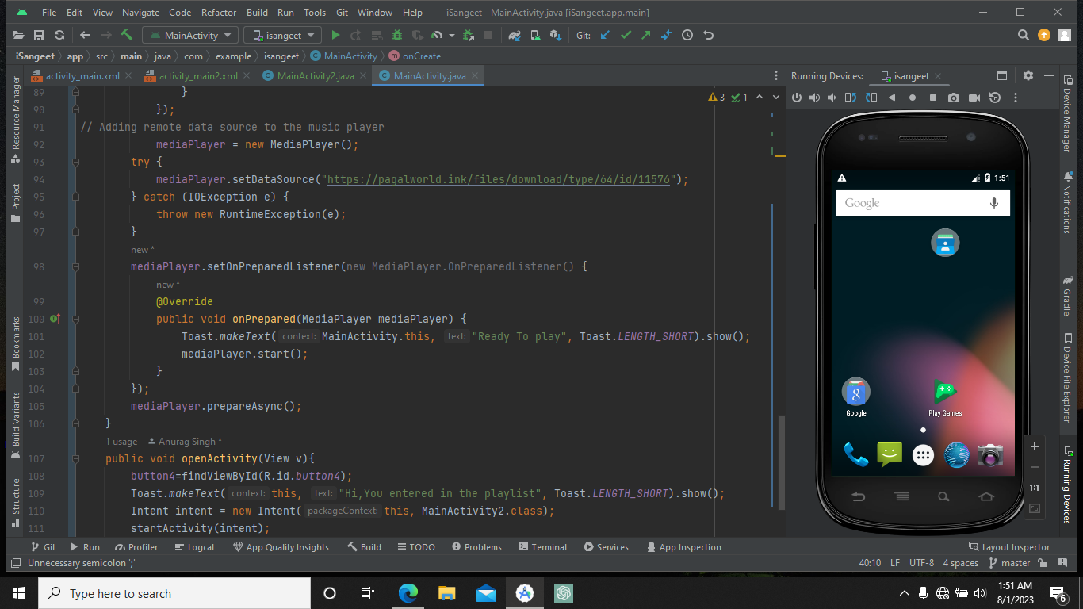

* 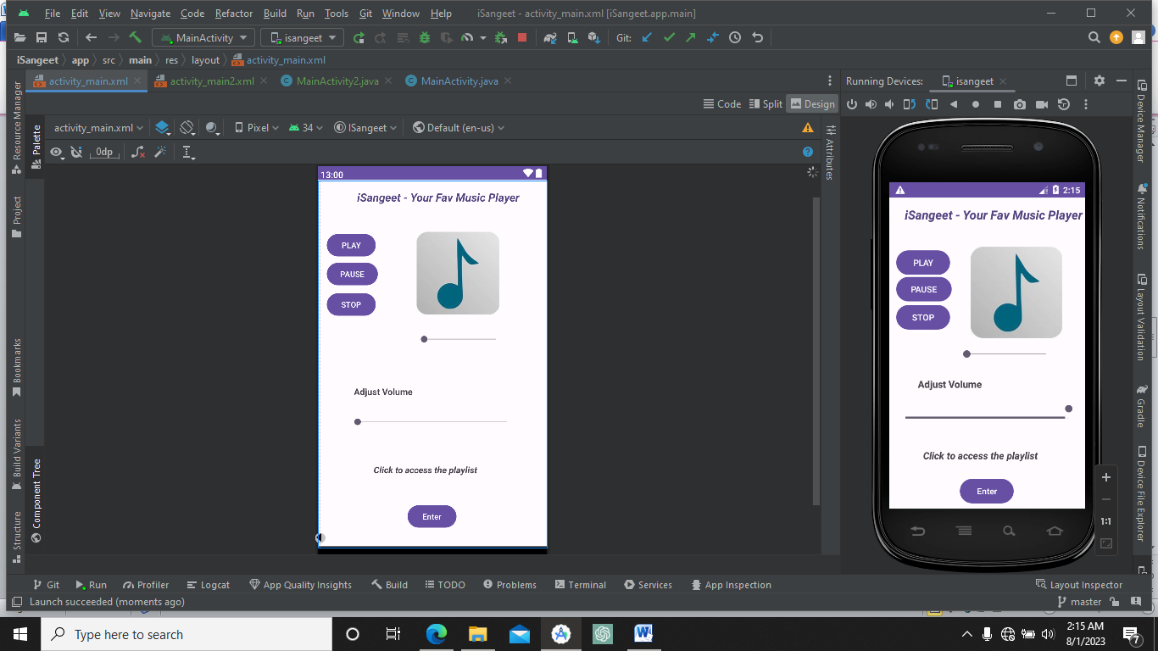
* **Setting up the surface View in the second view of the app with play and pause button.**

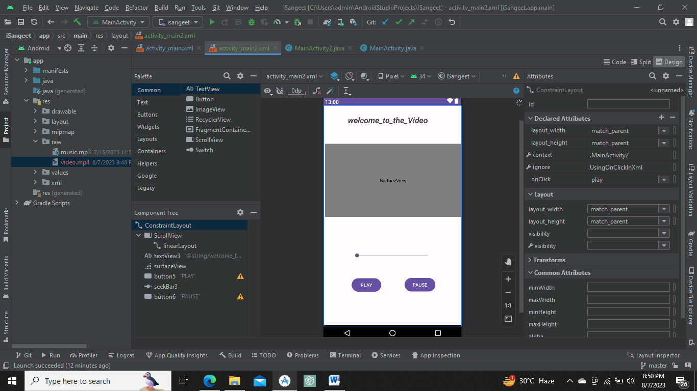

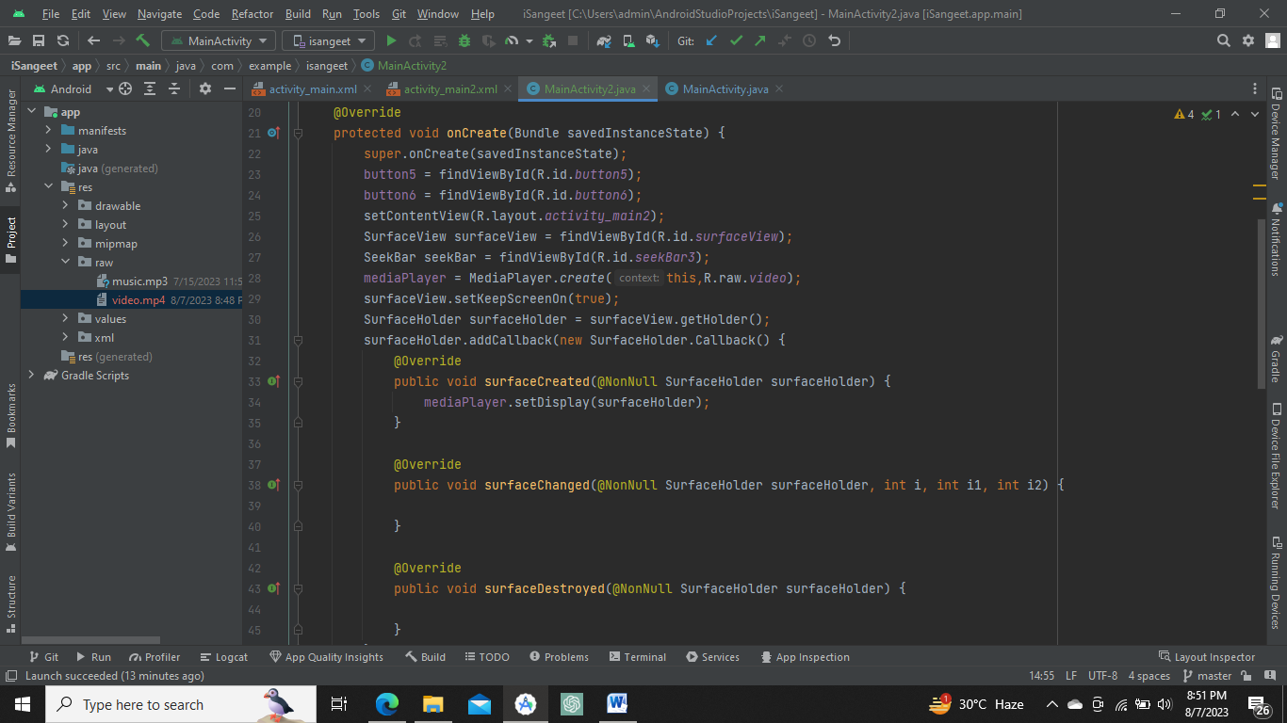

* **Setting up the Seekbar in second activity with seekprogress.**

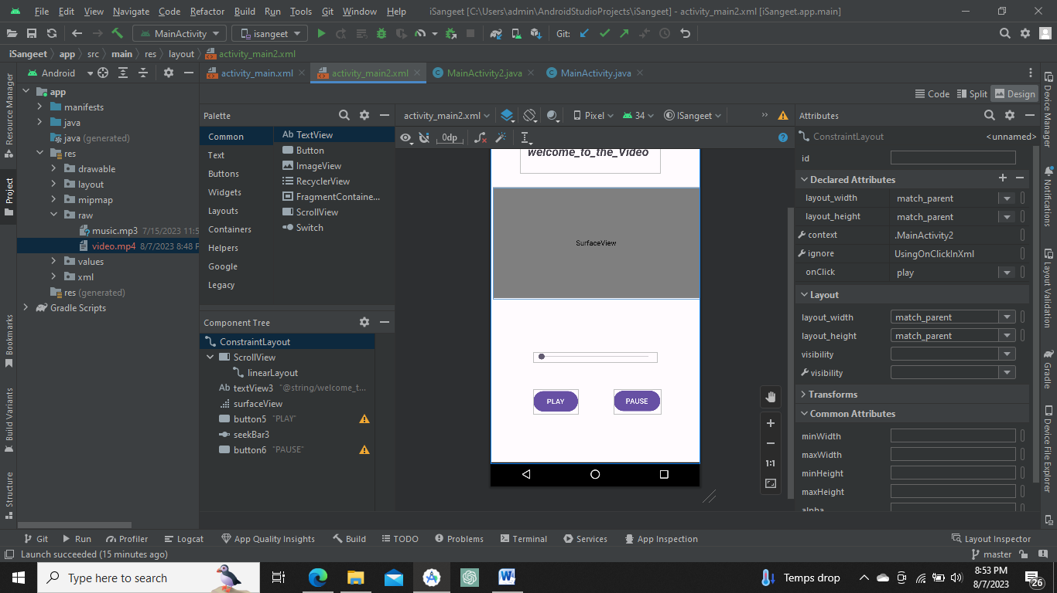

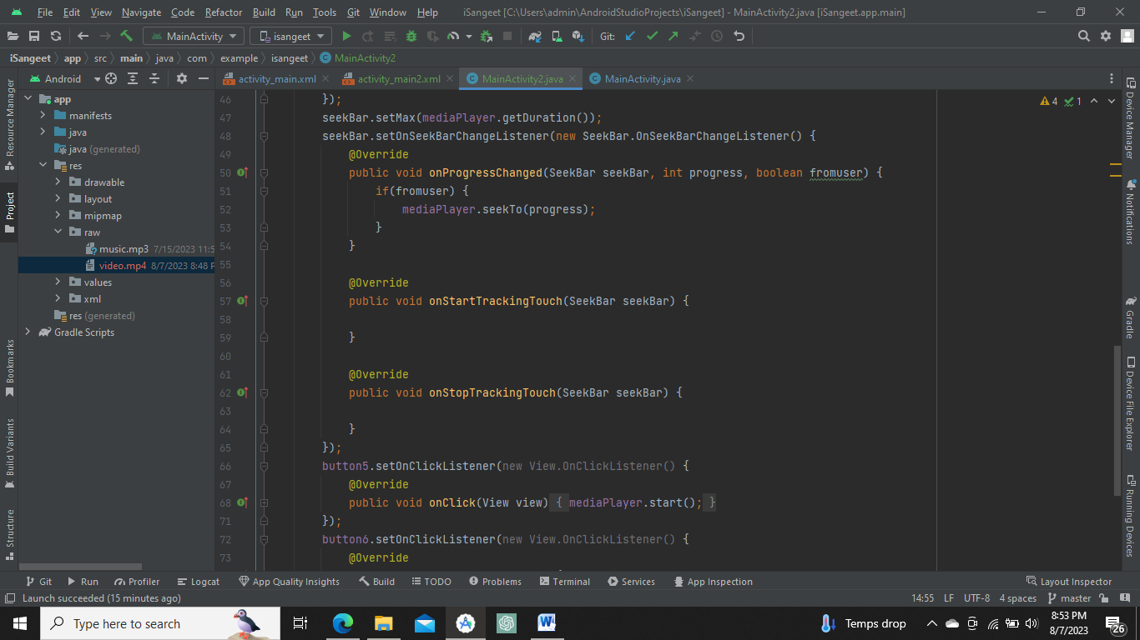

* **Challenges Faced:**

1. While Playing Video in second Surface view app was getting crashed.
2. Video size Compatability issue.

* **Next Week Objective:**

1. Database Management in isangeet app.
2. Provide functionality to efficient web music.
3. Replacing button with vector asset.

Git hub link - [anuragsingh-003/iSangeet (github.com)](https://github.com/anuragsingh-003/iSangeet)